Call Buying

You can profit from an increase in a stock’s price by purchasing a call.

Buying calls is popular with options investors, novices and experts alike. The strategy is simple: You buy calls on a stock or other equity whose market price you think will be higher than the strike price plus the premium by the expiration date. Or, you buy a call whose premium you think will increase enough to outpace time decay. In either case, if your expectation is correct, you may be in a position to realize a positive return. If you’re wrong, you face the loss of your premium—generally much less than if you had purchased shares and they lost value.

INVESTOR OBJECTIVES
Call buying may be appropriate for meeting a number of different objectives. For example, if you’d like to establish a price at which you’ll buy shares at some point in the future, you may buy call options on the stock without having to commit the full investment capital now. Or, you might use a buy low/sell high strategy, buying a call that you expect to rise and hoping to sell it after it increases in value. In that case, it’s key to pick a call that will react as you expect, since not all calls move significantly even when the underlying stock rises.

Some experienced investors may purchase calls in order to hedge against short sales of stock they’ve made. Investors who sell short hope to profit from a decrease in the stock’s price. If the shares increase in value instead, they can face heavy losses. Buying calls allows short sellers to protect themselves against the unexpected increase and limit their potential risk.

CALLING FOR LEVERAGE
One major appeal of purchasing calls is the possibility of leveraging your investment and realizing a much higher percentage return than if you made the equivalent stock transaction.

Investor A

Investor A buys 100 shares of company LMN stock at $10 each, investing a total of $1,000.
100 Shares
x $ 10 Per share
= $ 1,000 Investment

In the next year, the stock rises in value to $15.

Investor A sells and makes $500, or a50% return on his initial investment.
100 Shares
x $ 15 Per share
= $ 1,500 Sale price

$1,500 Sale price
– $1,000 Investment
=$ 500 Profit or
50% return

Investor B

Investor B, however, invests the same $1,000 in options, buying 20 calls at a strike price of $12.50. Each call cost her $50, or 50 cents per share, since her contract covers 100 shares.
$ 50 Per call
x 20 Calls
= $ 1,000 Investment

When the stock goes upto $15, her options are in-the-money by $2.50. Therefore, the value of her calls rises from 50 cents at purchase to at least $2.50 per share, a $200 gain per contract.

At expiration the 20 contracts are now worth $5,000, or $4,000 above what she invested, a 400% return.
CALLS
$250 ($2.50 per share)
$ 250 Per call
x 20 Calls held
= $ 5,000 Sale price

$5,000 Sale price
– $1,000 Investment
= $4,000 Profit or
400% return

PERFECT TIMING
Buying calls can provide an advantage over several different time periods:

Short term. Investors can profit
if they sell an option for more than they paid for it, for example if there is an increase in the stock’s price before expiration.

Medium term.
Over a matter of several months, investors can use call options to minimize the risk of owning stock in an uncertain market. Investors who want to lock in a purchase price for a year or longer can buy LEAPS, or periodically purchase new options.

Long term.
LEAPS allow investors to purchase calls at a strike price they’re comfortable with and accumulate the capital to purchase those shares in the intervening time until expiration.

BETTER THAN MARGIN
For certain investors, buying calls is an attractive alternative to buying stock on margin. Calls offer the same leverage that you can get from buying on margin, but you take on less potential risk. If you buy stock on margin, you must maintain a certain reserve of cash in your margin account to cover the possible loss in value of those stocks. If the stock price does fall, you must add cash to meet the margin requirement, liquidate a portion of your position, or face having your brokerage firm liquidate your assets. If you purchase calls, you have the same benefit of low initial investment as the margin trader, but if the value of the stock drops, the main risk you face is loss of the premium, an amount that’s usually much smaller than the initial margin requirement.

EXERCISING YOUR CALLS
Most call contracts are sold before expiration, allowing their holders to realize a profit if there are gains in the premium. If you’ve purchased a call with the intent of owning the underlying instrument, however, you can exercise your right at any time before expiration, subject to the exercise cut-off policies of your brokerage firm. However, if you don’t resell and don’t exercise before expiration, you’ll face the loss of all of the premium you paid. If your call is out-of the-money at expiration, you most likely won’t exercise. If your option is at-the-money, transaction fees may make it not worth exercising. But if your option is in-the-money, you should be careful not to let expiration pass without acting.

CHOOSING A SECURITY
In general, purchasing calls indicates a bullish sentiment, so you should consider a stock or stock index whose price you think is set to rise. This might be a stock you feel will rise in the short term, allowing you to profit from an increase in premium. You might also look for a stock with long-term growth potential that you’d like to own. Purchasing calls allows you to lock in an acceptable price, at the cost of the premium you pay.

PAY OF CHART
On October 1, 2010, Nifty is at 6143.40. You buy a call option with strike price of 6200 at a premium of Rs. 118.35 with expiry date October 28, 2010. A Call option gives the buyer the right, but not the obligation to buy the underlying at the strike price. So in this example, you have the right to buy Nifty at 6200. You may buy or you may not buy, there is no compulsion. If Nifty closes above 6200 at expiry, you will exercise the option, else you will let it expire. What will be your maximum profits/ losses under different conditions at expiry, we will try to find out using pay off charts.
If Nifty closes at 6100, you will NOT exercise the right to buy the underlying (which you have got by buying the call option) as Nifty is available in the market at a price lower than your strike price. Why will you buy something at 6200 when you can have the same thing at 6100? So you will forego the right. In such a situation, your loss will be equal to the premium paid, which in this case is Rs. 118.35
If Nifty were to close at 6318.35, you will exercise the option and buy Nifty @ 6200 and make profit by selling it at 6318.5. In this transaction you will make a profit of Rs. 118.35, but you have already paid this much money to the option seller right at the beginning, when you bought the option. So 6318.35 is the Break Even Point (BEP) for this option contract. A general formula for calculating BEP for call options is strike price plus premium (X + P).
If Nifty were to close at 6700, you will exercise the option and buy Nifty at 6200 and sell it in the market at 6700, thereby making a profit of Rs. 500. But since you have already paid Rs. 118.35 as option premium, your actual profit would be 500 – 118.35 = 381.65.
For profits/losses for other values, a table is given below. This table is used to draw the pay off chart

Strike Price (X) |  |  |  | 6200
Premium |  |  |  | 118.35
Nifty at Expiry | Premium Paid |  | Buy Nifty at |  | Sell Nifty at |  | Pay off for Long Call Position
A |  | B |  | C |  | D = A + B + C
6100 | -118.35 |  | -6100 |  | 6100 |  | -118.35
6150 | -118.35 |  | -6150 |  | 6150 |  | -118.35
6200 | -118.35 |  | -6200 |  | 6200 |  | -118.35
6250 | -118.35 |  | -6200 |  | 6250 |  | -68.35
6300 | -118.35 |  | -6200 |  | 6300 |  | -18.35
6350 | -118.35 |  | -6200 |  | 6350 |  | 31.65
6400 | -118.35 |  | -6200 |  | 6400 |  | 81.65
6450 | -118.35 |  | -6200 |  | 6450 |  | 131.65
6500 | -118.35 |  | -6200 |  | 6500 |  | 181.65
6550 | -118.35 |  | -6200 |  | 6550 |  | 231.65
6600 | -118.35 |  | -6200 |  | 6600 |  | 281.65
6650 | -118.35 |  | -6200 |  | 6650 |  | 331.65
6700 | -118.35 |  | -6200 |  | 6700 |  | 381.65

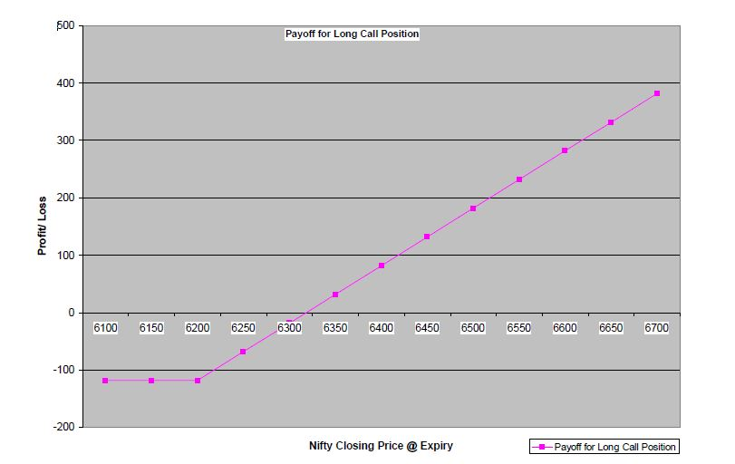

The contract value for a Nifty option with lot size of 75 and strike price of 6200 is 75 * 6200 = 465000.
The maximum loss for such an option buyer would be equal to 118.35 * 75 = 8876.25
As Nifty goes above 6318.35 you start making profit on exercising the option and if it stays below 6318.35, you as a buyer always have the freedom not to exercise the option. But as seen from table and chart you can reduce your losses as soon as nifty goes above 6200. Long call position helps you to protect your loss to a maximum of Rs. 5917.5 with unlimited profit.

